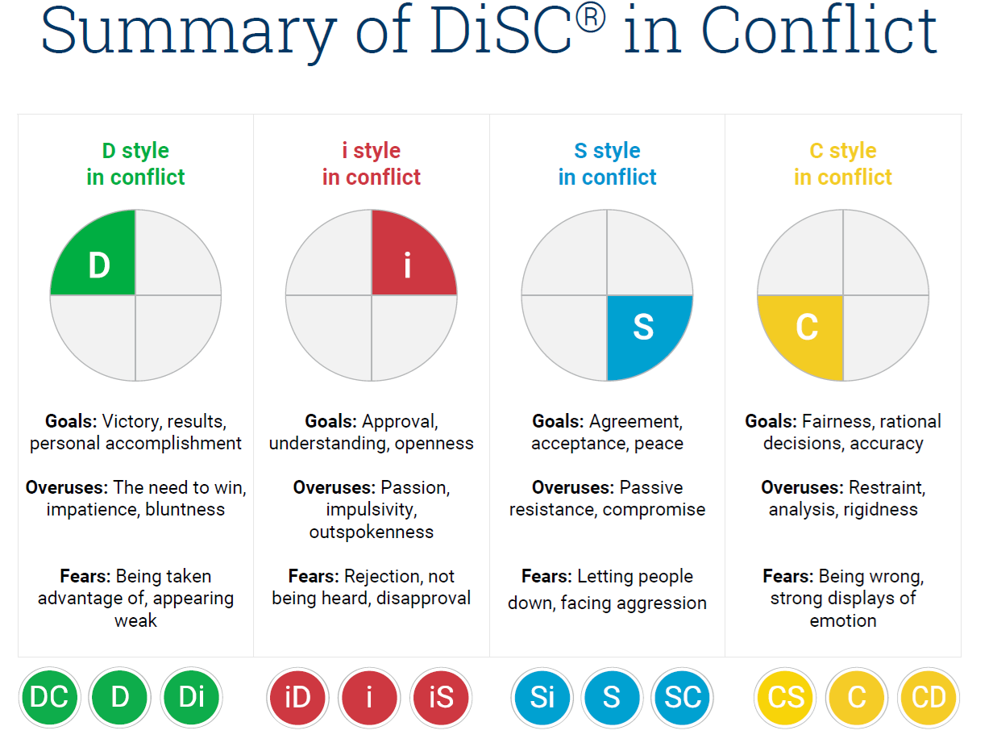
Think of a conflict situation you were in that you wish you would have handled better.

- Looking at the above chart, how do you think your DiSC style impacted the situation or outcome?

- What was your response to the situation?

- What were some automatic thoughts that may have influenced that response?

